Ileal lactobezoar in an extreme premature infant complicated by intestinal perforation: A case report

Mohamed Elkhouli ^{a, c}, Farid Aleali ^{a, c}, Ayah Alzamrooni ^{b,c}, Priscilla Chiu ^{b,c}, Estelle Gauda^{a, c}

ª Neonatology Department, The Hospital for Sick Children, Toronto, Ontario, Canada
^{b} Division of General and Thoracic Surgery, The Hospital for Sick Children, Toronto, Ontario,
Canada
^{c} University of Toronto, Toronto, Ontario, Canada

Corresponding author:
Dr. Estelle Gauda
555 University Avenue
M5G 1X8, Toronto,
Ontario, Canada
Email: Estelle.gauda@sickkids.ca

ABSTRACT:

Introduction: Lactobezoar, which is characterized by an aggregation of mucus and undigested milk, is a rare gastrointestinal complication that has been reported to occur predominately in the stomach of high-caloric formula-fed infants. Despite significant advances in the development of more physiologic formula compositions, an increased incidence of lactobezoar in extremely premature infants has been observed recently.
Case presentation: We herein report a case of ileal perforation secondary to a lactobezoar in a preterm male infant (26 weeks GA) on day 18 of life, 48 hours after initiation of human milk fortification (HMF). The initial presentation seemed to be in keeping with the diagnosis of necrotizing enterocolitis (NEC). However, exploratory laparotomy revealed a large blow-out ileal perforation associated with an intraluminal, inspissated mass distal to it, in keeping with a lactobezoar without evidence for NEC. The compromised ileum was resected and an ileostomy and mucous fistula were performed. Postoperatively, the patient recovered well. Feeding was successfully restarted on day 14 post-op. The ileostomy was reversed nine weeks after the initial surgery.
Discussion: Lactobezoar is a rare cause of neonatal intestinal obstruction. However, with the increasing survival of extremely preterm infants, a continuous increase in its incidence could be experienced also in the upcoming years. It is most commonly located in the stomach, but as our case demonstrates, it can also cause mechanical obstruction in other areas of the intestine. In the last decade, HMFs have been reported as the number one cause of its occurrence.
Conclusion: Lactobezoar should be considered in the differential diagnosis of neonatal gastrointestinal problems, especially in extremely premature infants receiving HMF.

KEYWORDS: lactobezoar, ileal perforation, necrotizing enterocolitis, laparotomy, ileostomy, milk curd obstruction, human milk fortifier

1. INTRODUCTION

Due to their fragility, preterm, and in particular, extremely preterm infants (≤28 weeks of gestation) are generally at an increased risk for serious life-threatening gastrointestinal (GI) problems and their sequelae. Among the various severe GI conditions, necrotizing enterocolitis (NEC) is the most commonly encountered [1]. It is a devastating disease that is associated with severe sepsis, intestinal perforation, and significant morbidity and mortality [2]. NEC affects 3 to 5% of all low-birth-weight live births with an increasing incidence in extreme prematurity [3, 4].
However, in the preterm period, there are also rarer GI conditions that can be easily mislabeled as NEC as they are able to very closely resemble its clinical and radiological presentation. These include spontaneous intestinal perforation (SIP), volvulus with/or without malrotation, meconium ileus as well as the phenomenon of lactobezoar [5-7]. The latter is caused by an aggregation of mucus and undigested milk that is found primarily in the stomach [5]. Due to its rare occurrence, the diagnosis of lactobezoar can be quite challenging and is often made intra-operatively. Human milk fortifiers (HMFs), which have become common practice in most neonatal units and supplement human milk with calcium, phosphorus and protein, seem to play a crucial role in the pathogenesis of lactobezoar, especially in the last decade [8, 9].
Herein, we report on a case of a premature infant pre-operatively diagnosed with intestinal perforation secondary to NEC, with the intra-operative finding of an ileal lactobezoar as the actual cause for intestinal perforation.
This work has been reported in line with the SCARE 2020 criteria [10] as well as the PROCESS criteria [11].
2. CASE REPORT
We present a case of a 900-gram male that was born to a 30-year-old healthy mother by vaginal delivery at 26 weeks of gestation. Apgar scores were 8 at 1min and 8 at 5 min. Other than the preterm onset of labor, the pregnancy was uncomplicated. Mum’s medical history was negative for diabetes and hypertension, as well as for alcohol and drug abuse. The family history was negative for GI diseases.
After birth, the newborn was maintained on nasal CPAP for the treatment of respiratory distress syndrome and received a dose of surfactant, as well as caffeine as part of the routine preterm care. Gavage feeding with maternal expressed breast milk (EBM) was started on day 2 of life (DOL 2) and was fortified up to 24 kcal/oz with hydrolyzed formula on DOL 16. On DOL 18, the patient developed significant apnea requiring intubation and mechanical ventilation. On physical exam, significant abdominal distension as well as abdominal wall erythema were noted. Feeds were immediately discontinued and a nasogastric tube for abdominal decompression was inserted. A full septic work-up was initiated and the patient was empirically started on vancomycin, cefotaxime and metronidazole. Initial laboratory tests revealed leukopenia (WBC 5.81 × 109/L), anemia (Hgb 113 g/l), thrombocytopenia (Plt 54 × 109/L), and a C-reactive protein of 73 mg/L. Arterial blood gas analysis showed significant metabolic acidosis (pH 7.05) and elevated lactic acid (7 mmol/L). The patient continued to develop signs and symptoms of septic shock and peritonitis, requiring volume expanders and vasopressor support. An emergent transfer to the neonatal intensive care unit of The Hospital for Sick Children in Toronto was initiated. Upon arrival, supine anteroposterior and left lateral decubitus radiographs revealed distended bowel loops in the ileocolic region. Radiographs showed no concrete evidence for pneumoperitoneum, but revealed an opacity in the right lower quadrant [Figs 1+2]. Abdominal ultrasonography showed signs of echogenic debris in the mid and left abdomen, thus raising the suspicion for an intestinal perforation. Based on the clinical and imaging findings, the baby was taken to the operating room for urgent exploratory laparotomy.
Intraoperatively, a significant amount of serous ascites and partially digested feeds were found. The ileum was found to be frankly perforated approximately 12 cm proximal from the ileocecal valve [Fig. 3]. Distal to the perforation, there was a firm mass stuck within the lumen of the terminal ileum. The mass was easily retrieved and appeared to be a bezoar of inspissated milk [Fig. 4]. Bowel continuity was evaluated and no web, atresia or further extra-or intraluminal mechanical obstruction were identified. The remaining small bowel was normal in appearance without evidence of necrotizing enterocolitis. In total, 7 cm of ileum were resected. Given the patient’s hemodynamic instability and intra-operative difficulties in ventilation, the surgeon decided for an ileostomy. The pathological examination of the resected ileum revealed ischemic changes without evidence of atresia or web and with normal ganglion cells present. Analysis of the hard, inspissated mass confirmed a lactobezoar.
Within 12 hours from surgery, the patients’ condition improved, allowing for stepwise discontinuation of vasopressor support. Intravenous antibiotics were continued for a full 10-day course. Feeds were restarted on day 14 post-op and full enteral feeds were achieved on postoperative day 50. Ileostomy reversal was successfully performed 9 weeks after the initial laparotomy. The patient was recently seen in neonatal and surgical follow-up clinic (at corrected 4 months of age) and is thriving well on full enteral feeds.
3. DISCUSSION
Lactobezoar as a cause of intestinal obstruction in infants has been known since 1959, when Wolf and Bruce first reported on a term neonate with lactobezoar that had been fed with infant formula containing high levels of the milk protein casein [12]. In the 1970s, the introduction of formulas with more physiologic casein concentrations resulted in a significant reduction in the occurrence of lactobezoar [13]. Interestingly, there has recently been a rise in cases, likely due to the introduction of human milk fortification in extreme premature infants [8, 9, 13, 14]. Due to immaturity of the gut, premature babies have delayed gastric emptying and bile acid secretion, with diminished gastric fluid volume, acid secretion, pepsin activity, and bile salt concentration. All these factors contribute to the slow absorption and delay in gastric and intestinal transit time [15]. HMFs may lead to further delay in absorption and transit time, resulting in the formation of concretions in the neonatal GI tract. However, its exact pathogenesis has not been fully elucidated yet.
In our case, the use of HMF seemed to be the cause of the lactobezoar formation. The first larger case series including 9 babies with lactobezoar due to milk fortification was reported by Wagener et al. in 2009 [16]. The onset of symptoms was reported to range between 3 and 47 days after the start of fortification. In 2014, Stanger et al reported a series of 8 premature infants with gastric lactobezoar with onset of symptoms between 7 and 11 days post fortification [8]. Most recently, the so far largest series of premature infants with gastric lactobezoar has been reported by Longardt et al in 2019, including a total of 10 cases that had all received HMF [9]. In comparison to the data available in the literature, our patient had a fairly early onset of symptoms, that is only 48 hours post fortification.
The signs and symptoms with which premature patients most commonly present are fairly nonspecific and include apnea, desaturations, feeding intolerance, vomiting, bilious aspirates, abdominal distention, poor weight gain, diarrhea, a palpable abdominal mass, intestinal obstruction up to gastric or intestinal perforation [13]. It is therefore not uncommon that these patients are initially misrecognized as stage II NEC, as it was the case in our patient [5, 17]. However, there have been also several cases reported in the literature, whereby patients were found to have co-occurrence of NEC and lactobezoar [18, 19]. Besides the similarity of symptoms and signs of both conditions (i.e. sepsis, abdominal distension, pneumatosis), the above mentioned concomitant onset of symptoms after fortification, which is often described in patients with NEC, contributes to the challenge in diagnosis. Furthermore, it is possible that the two conditions give rise to each other: NEC leading to a paralytic ileus resulting in the presence of undigested clotted milk, as well as a lactobezoar leading to obstruction and distension resulting in hypo-perfusion of the bowel [19].
As of to date, there are 133 cases of pediatric lactobezoar described in the literature, out of which more than two thirds occurred in premature babies [13]. In the last decade, 23 out of the 33 reported cases were associated with HMF. With regards to the location in the GI tract, there have been only 6 cases so far described in the literature that had a lactobezoar – like in our case - located outside the stomach [13,20]. It remains unclear, whether these intestinal bezoars are dislodgements from the stomach, or have actually formed in the small or large intestine. 5. Conclusion
We describe a case of ileal lactobezoar complicated by intestinal perforation in an extremely premature infant shortly after initiation of HMF. Based on our patients’ findings, we conclude that lactobezoar can develop surprisingly shortly after introduction of HMF, can be located outside of the typical location of the stomach in the small intestine, and can be easily mislabeled as NEC given its similarity in clinical and radiological findings. Lactobezoar should be considered as differential diagnosis to more commonly encountered GI conditions in premature patients with GI symptoms, especially in patients with history of recent HMF initiation. Early recognition of this potential complication of milk fortification can prevent the evolution of more serious complications.

Acknowledgements
The authors would like to acknowledge Dr. Elke Zani-Ruttenstock for her assistance with the preparation of the manuscript.

Provenance and peer review:
Not commissioned, externally peer-reviewed.
Conflicts of interest:
N/A
Sources of funding:
N/A
Ethical approval:
N/A
Consent:
Written informed consent was obtained from the patient for publication of this case report and accompanying images. A copy of the written consent is available for review by the Editor-in-Chief of this journal on request.
Author contribution:
Mohamed Elkhouli and Farid Aleali had equal contribution as co-authors in collecting the data of the patient, checking the literature review and writing the discussion. Ayah Alzamrooni was responsible for the surgical part of the history of the patient. Dr Chiu helped in revising the paper. Dr Gauda helped in writing and revising the paper as well as with supervision of the team.
Guarantor:
Dr. Estelle Gauda.

Figures:
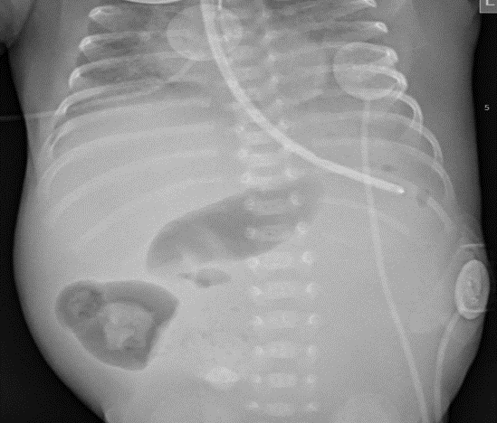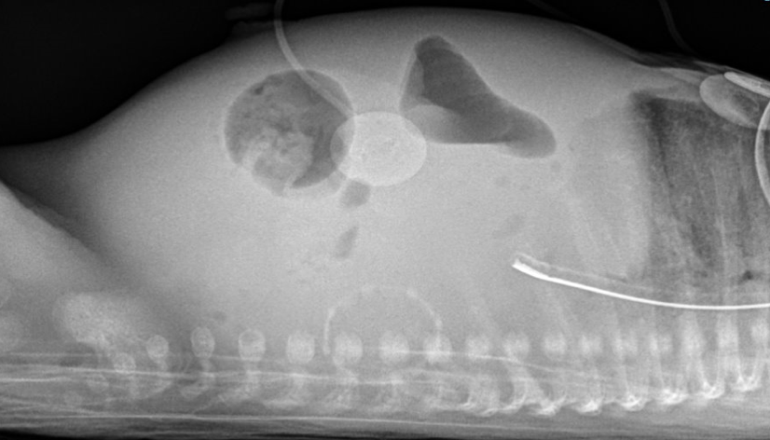
Figure 1: AP view Figure 2: Lateral cross-table view

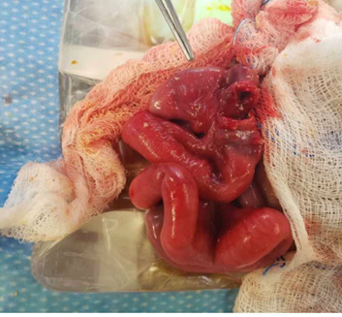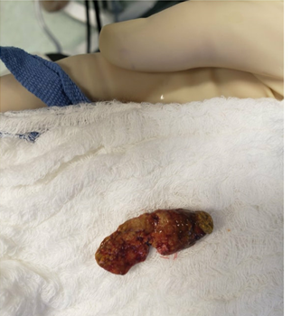
Figure 3: Image of dilated ileum proximal to obstruction figure 4: Lactobezoar extracted from ileum

References:
1. Gregory KE, Deforge CE, Natale KM, Phillips M, Van Marter LJ: Necrotizing enterocolitis in the premature infant: neonatal nursing assessment, disease pathogenesis, and clinical presentation. Adv Neonatal Care 2011, 11(3):155-164; quiz 165-156.
2. Henry MC, Moss RL: Necrotizing enterocolitis. Annual review of medicine 2009, 60:111-124.
3. Mutanen A, Pierro A, Zani A: Perioperative Complications Following Surgery for Necrotizing Enterocolitis. European journal of pediatric surgery : official journal of Austrian Association of Pediatric Surgery [et al] = Zeitschrift fur Kinderchirurgie 2018, 28(2):148-151.
4. Moss RL, Kalish LA, Duggan C, Johnston P, Brandt ML, Dunn JC, Ehrenkranz RA, Jaksic T, Nobuhara K, Simpson BJ et al: Clinical parameters do not adequately predict outcome in necrotizing enterocolitis: a multi-institutional study. Journal of perinatology : official journal of the California Perinatal Association 2008, 28(10):665-674.
5. Bos ME, Wijnen RM, de Blaauw I: Gastric pneumatosis and rupture caused by lactobezoar. Pediatrics international : official journal of the Japan Pediatric Society 2013, 55(6):757-760.
6. Gordon PV, Swanson JR, Attridge JT, Clark R: Emerging trends in acquired neonatal intestinal disease: is it time to abandon Bell's criteria? Journal of perinatology : official journal of the California Perinatal Association 2007, 27(11):661-671.
7. Montalva L, Ali LH, Héneau A, Julien-Marsollier F, Biran V, Bonnard AJTIJoP: Misdiagnosing Midgut Volvulus in Very Preterm Infants: What is the Impact of Delay Before Surgery? 2020, 88:89-90.
8. Stanger JD, Zwicker K, Albersheim SG, Murphy JJJJops: Human milk fortifier: an occult cause of bowel obstruction in extremely premature neonates. 2014, 49 5:724-726.
9. Longardt AC, Loui A, Bührer C, Berns M: Milk Curd Obstruction in Human Milk-Fed Preterm Infants. Neonatology 2019, 115(3):211-216.
10. Agha RA, Franchi T, Sohrabi C, Mathew G, Kerwan A: The SCARE 2020 Guideline: Updating Consensus Surgical CAse REport (SCARE) Guidelines. International journal of surgery (London, England) 2020, 84:226-230.
11. Agha RA, Borrelli MR, Farwana R, Koshy K, Fowler AJ, Orgill DP: The PROCESS 2018 statement: Updating Consensus Preferred Reporting Of CasE Series in Surgery (PROCESS) guidelines. International journal of surgery (London, England) 2018, 60:279-282.
12. Wolf RS, Bruce J: Gastrotomy for lactobezoar in a newborn infant. The Journal of pediatrics 1959, 54(6):811-812.
13. Heinz-Erian P, Gassner I, Klein-Franke A, Jud V, Trawoeger R, Niederwanger C, Mueller T, Meister B, Scholl-Buergi S: Gastric lactobezoar - a rare disorder? Orphanet journal of rare diseases 2012, 7:3.
14. Flikweert ER, La Hei ER, De Rijke YB, Van de Ven K: Return of the milk curd syndrome. Pediatric Surgery International 2003, 19(9):628-631.
15. Kempley ST, Sinha AK, Thomas MR: Which milk for the sick preterm infant? Current Paediatrics 2005, 15(5):390-399.
16. Wagener S, Cartwright DW, Bourke CJJoP, Health C: Milk curd obstruction in premature infants receiving fortified expressed breast milk. 2009, 45.
17. Berkowitz GP, Buntain WL, Cassady G: Milk curd obstruction mimicking necrotizing enterocolitis. American journal of diseases of children (1960) 1980, 134(10):989-990.
18. Mandel D, Lubetzky R, Mimouni FB, Dollberg S: Lactobezoar and necrotizing enterocolitis in a preterm infant. The Israel Medical Association journal : IMAJ 2003, 5(12):895-896.
19. Jain A, Godambe SV, Clarke SR, Chow PJBCR: Unusually late presentation of lactobezoar leading to necrotising enterocolitis in an extremely low birthweight infant. 2009, 2009.
20. Chuang YH, Fan WL, Chu YD, Liang KH, Yeh YM, Chen CC, Chiu CH, Lai MW: Whole-Exome Sequencing Identified Novel CLMP Mutations in a Family With Congenital Short Bowel Syndrome Presenting Differently in Two Probands. Front Genet. 2020 Dec 15;11:574943.

